**Blood and Circulation**

The circulatory system consists of three organs. They are:



Its function is to transport various substances around the body. Some of these are:

_______________________________________________________________

**Blood**

The human body has about _____ litres of blood. Human blood is made of four components; plasma, red blood cells, white blood cells and platelets.

**Plasma**

Plasma is the main component of blood, consisting mainly of _______ . It is pale ________ in colour. Plasma carries ___________ _______ , ___________ and _______ . Suspended in the plasma are the ________ and ____ blood cells and __________ .

**Red Blood Cells**

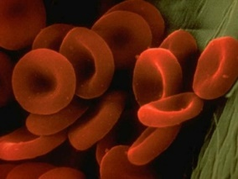Red blood cells carry _____ throughout the body. Oxygen combines with an _____ containing chemical called _________________ in the blood cells. Red blood cells are _______ shaped and do not have a ___________ .

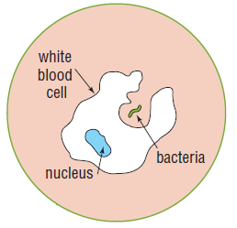**White Blood Cells**

White blood cells are _________ and _____ ___________ than red blood cells. They have ___ _________ _______ , but possess a __________ . White blood cells are mostly involved in __________ ____________ . They protect the body from disease by ‘eating’ _________ ___________ and __________ in the blood.

**Platelets**

Platelets are tiny cells with no _________ . They are involved in the ____________ ___ _________ . Platelets form sticky _______ that plug up damaged _________ _____________ .

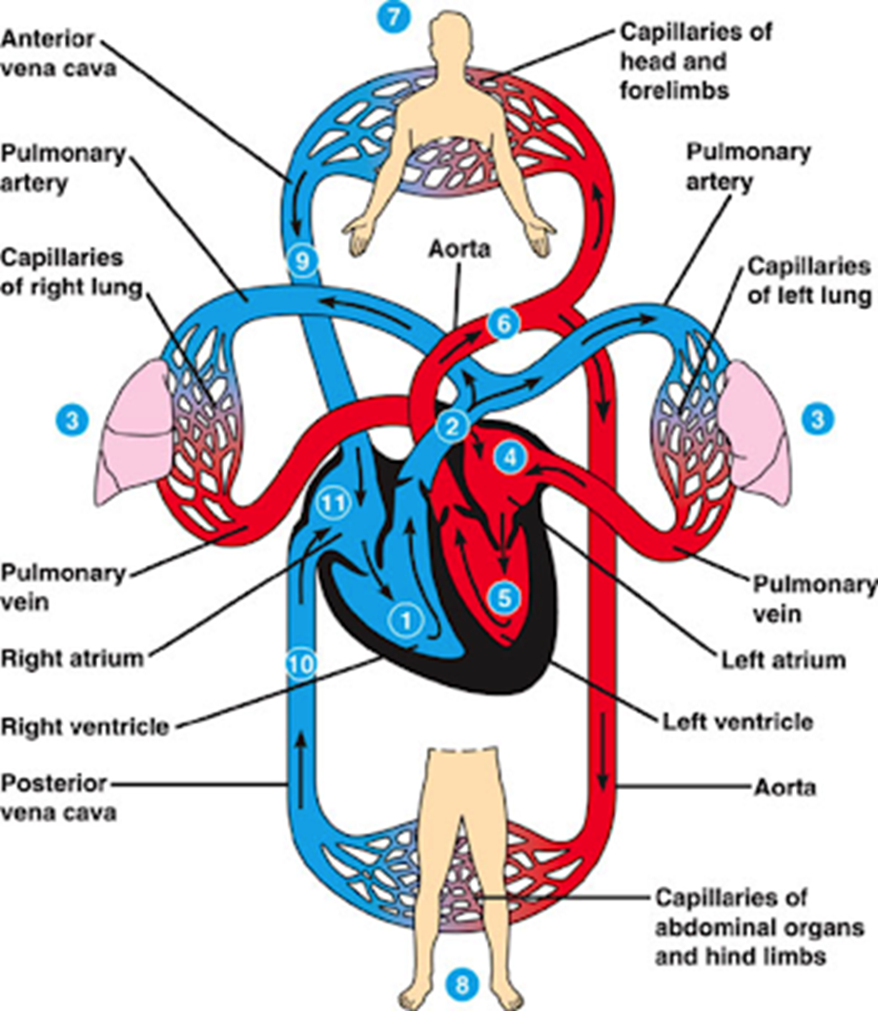

**Circulation**

1. Describe the path blood takes through the body from the right ventricle (1) to the left ventricle (5)

_________________________________________________________________________________________________________________________________________________________________________________________________________________________________________________________________________________________________________________

1. Describe the path blood takes from the left ventricle (5), back to the right ventricle (1)

_________________________________________________________________________________________________________________________________________________________________________________________________________________________________________________________________________________________________________________